# UNESP Logo – Universidade Estadual Paulista – PNG e Vetor – Download de ...USP Logo – Universidade de São Paulo - PNG e Vetor - Download de LogoEduSCar – Educação de qualidade para todos!

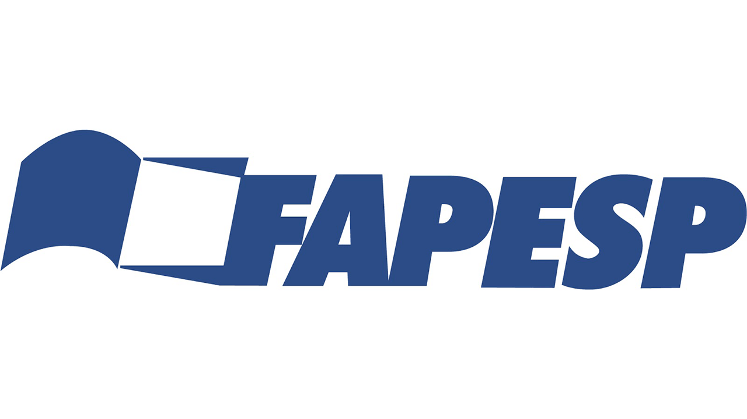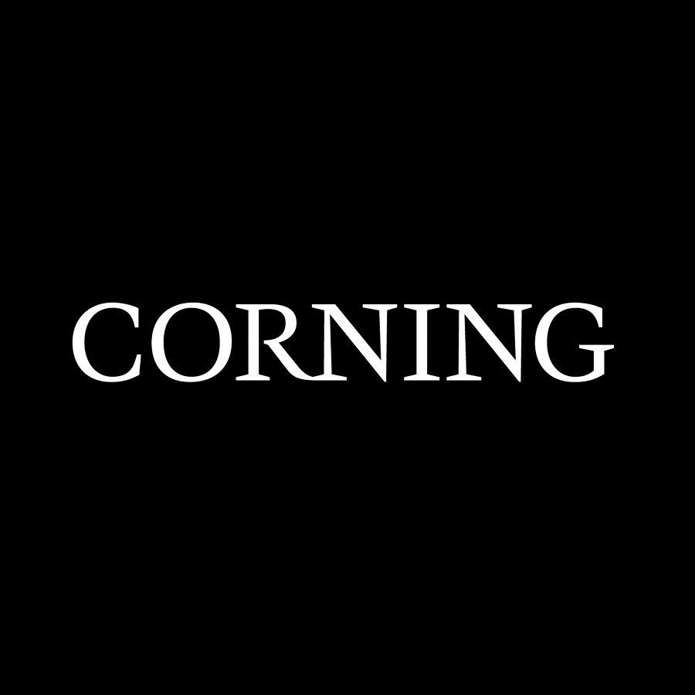 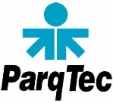 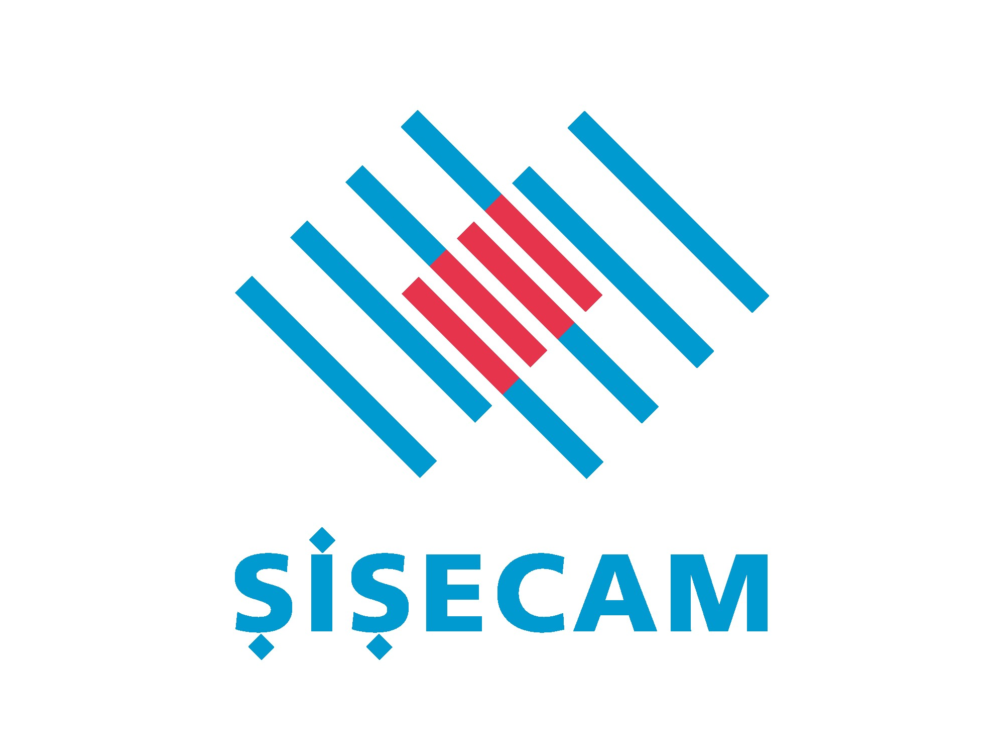

# ufscar-logo-2 – PNG e Vetor - Download de LogoAlfred University - Echo Deltahttp://ceramics.org/wp-content/uploads/2015/08/Glass-Summer-School-Brazil-620x350.png

# **THIRD *SÃO CARLOS SCHOOL ON GLASSES AND GLASS-CERAMICS***

*Vitreous Materials Lab (LaMaV) at Federal University of São Carlos (lamav.weebly.com). Instructors and attendees of the* ***First School*** *(2015) with 70 international students and 30 Brazilians.*

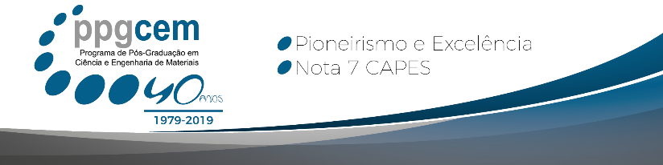 

**SCHOOL OBJECTIVES**

The CeRTEV team ([www.certev.ufscar.br](http://www.certev.ufscar.br)) is organizing the Third School on Glasses and Glass-ceramics from March 10 to 15, 2025 following the success of the First International School in 2015 and the Second in 2023. The main objectives of the school are:

* Provide state-of-the-art information on the structure, dynamic processes (diffusion, viscous flow, relaxation, and crystallization), and optical, electrical, mechanical, and bio-chemical properties of glasses and glass-ceramics.
* Disseminate CeRTEV’s faculty, infrastructure, and facilities to Brazilian and international students.
* Strengthen the international network of CeRTEV collaborators.
* Attract future students, post-docs, and visiting scientists and foster collaborative research.

The instructors are well-known experts in experimental, theoretical, and computer simulation studies of glasses. Several professors from the NYSCC Alfred University, USA, will join us this year.

**LOGISTICS**

Approximately **70** Ph.D. and M.Sc. students and a few young researchers from several countries have registered. The school will have approximately 40 hours of classes, poster presentations, and discussions over six days.

The post-graduate program in materials science and engineering of the Federal University of São Carlos (PPGCEM – DEMa, CAPES level 7 = top in Brazil) validates this course.

Seven students have enrolled and will receive course credits upon completion of a home work.

# **ORGANIZERS**

Prof. Edgar D. **Zanotto** – **CeRTEV** director (dedz@ufscar.br)

Prof. Hellmut **Eckert** – **CeRTEV** vice-director

Prof. Ana C.M. **Rodrigues** – Education and Science Outreach coordinator

Prof. Eduardo B. **Ferreira** – Technology and Innovation coordinator

Ricardo **Lancelotti** – PhD Student

Administrative assistant – Miss Laurie Leonardo ([certevlamav@gmail.com](mailto:certevlamav@gmail.com))

# **TENTATIVE PROGRAM AND INSTRUCTORS**

**CeRTEV Instructors**

Ana Candida M. **Rodrigues** – Electrical properties

Andréa S. S. **de Camargo** – Optical properties

Edgar Dutra **Zanotto** – Crystallization and glass-ceramics

Eduardo Bellini **Ferreira** – Glass sintering

Daniel R. **Cassar** – Glass design by machine learning

Hellmut **Eckert** – Glass structure by EPR

José Pedro **Rino** – MD simulations

Marcos de **Oliveira Junior** – Glass structure by NMR

Francisco **Serbena** – Mechanical properties of glass-ceramics

Marcelo **Nalin** – Photonic glasses

Paulo S. **Pizani** & Rafaella **Bartz** – Raman spectroscopy

Oscar **Peitl** – Bioactive glasses and glass-ceramics

**NYSCC - Alfred University, USA**

Shan K. **Sundaram** – Structure-terahertz property relationship in glasses

Doris **Möncke** – Spectroscopies, basicity, polyvalent ions, non-silicate oxide glasses

Collin **Wilkinson** – Glass relaxation

Rebecca **Welch** – Computational Modeling of Glasses: Statistical Mechanics Model of Glasses and Topological Constraint Theory

Benjamin **Moulton** – Spectroscopies (Structure of a variety of oxide glasses)

Caio **Bragatto** – Electrical properties of glasses

**Warsaw University of Technology, Poland**

Tomasz K. **Pietrzak –** Giant increase in the electron hopping conductivity in nano-crystallized phosphate glasses

**Industry Instructors**

AGC - Dr. Satoshi **Yoshida -** Indentation deformation and fracture of glasses

Sisecan – Dr. Banu **Arslan** – Recycled glass integration: Fundamental research for optimal batch composition

Corning - Dr. Timothy **Gross –** Mechanics of bendable glass substrates

Corning - Dr. Paulo **Daianese -** Optical metasurfaces: introduction and applications in optical communications

Arrival in São Paulo (GRU airport) or Campinas (Viracopos airport) on Sunday, **March 9, 2025**

**TENTATIVE PROGRAM**

|  |  |  |  |  |  |
| --- | --- | --- | --- | --- | --- |
| **Monday, 10/03/2025** | **Tuesday** | **Wednesday** | **Thursday** | **Friday** | **Saturday, 15/03/2025** |
| **8:00am**  **Welcome**  Key research topics at Alfred  **Alfred faculty** | Glass structure by Raman  **P.S.Pizani, R. Bartz, B. Moulton** | Optical properties  **A.De Camargo**  Photonic glasses  **M. Nalin** | MD simulations  **J.P.Rino**  Relaxation  **C. Wilkinson** | Crystallization and GCs  **E.D. Zanotto**  Glass sintering  **E.B. Ferreira** | Visit to the  glass labs at EESC-USP |
| **10:00** Short Coffee Break | | | | | |
| **10:15**  Key research topics at CeRTEV  **CeRTEV faculty** | Glass structure by EPR  **H. Eckert**  Glass structure by NMR  **M. Oliveira** | Spectroscopies Basicity, Colors  **D.** **Möncke**  Bio properties  **O. Peitl** | Computational modeling  R. **Welch**  Machine Learning  **D.R. Cassar** | Mechanical properties of GCs  **F. Serbena**  Electronic Prop.  **T. Pietrzak** | Visit to the glass labs at EESC-USP |
| **12:15** Lunch Break | | | | | |
| **13:45**  1 min fire talks by the  **Students** | Visit LaMaV and Electron Mic. Labs at UFSCar | Guided Tour to Sta. Maria Farm | Structure vs. properties  **S. Sundaram**  Ion Exchange  **B. Moulton** | Electrical Prop.  **A. C. Rodrigues**  Electrical Prop.  **C. Bragatto** | **Return to São Paulo (GRU) Airport** |
| Extended Coffee Break with Poster Session | | | | | |
| **16:30**  **Welcome reception** | Glass orchestra performance | Guided Tour | **Sisecam (16:30)** and **AGC (17:30)** lectures | **16:30 Corning** Lectures | MD simulations  **J.P.Rino** |
| **Welcome reception at ParqTec** | **International Snack Tasting** | Free | **Students night out** | **Farewell Dinner at UFSCar** |  |

**SPONSORS**

Fapesp - CeRTEV, DEMa-UFSCar, ParqTec São Carlos, NYSCC-Alfred University, ICG, Sisecam, and Corning.

# **CeRTEV INSTRUCTORS**

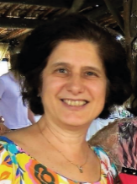 **Ana Candida M.** **Rodrigues** is a Professor at the Department of Materials Engineering of the Federal University of São Carlos. She has been teaching basic Materials Science and topics related to glass and electrical properties in both graduate and undergraduate courses, for 30 years. Her broader research interest includes **electrical properties of oxide glasses and glass-ceramics, glass crystallization, and solid electrolytes for solid state batteries**. Currently she is the chair of the Technical Committee TC23 “Glass Education” of the International Commission of Glass, and Education and Outreach Coordinator of the Center for Research, Technology, and Education in Vitreous Materials (CeRTEV).

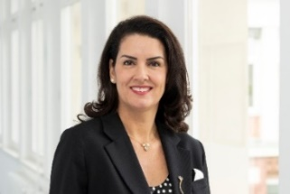 **Andréa S. S.** **de Camargo** holds a B.Sc. and M.Sc. in Chemistry and a PhD in Applied Physics. In 2008 she became an Alexander von Humboldt fellow in a 2-year research stay at the University of Münster. For 17 years she worked as a professor at the University of São Paulo in Brazil, where she led a productive lab focused on the development of **luminescent and optical materials**. In 2023 she accepted a new joint position in Germany, as Professor of University of Jena and the Head of Division 5.6 – Glass at the Federal Institute for Materials Research and Testing (BAM) in Berlin. She is an editor of J. Materials Science since 2020.

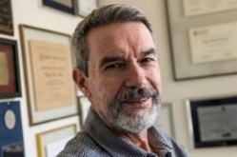 **Edgar Dutra Zanotto** has been a Professor of Materials Science and Engineering and Director of the Center of Education, Research, and Technology in Vitreous Materials - CeRTEV (www.certev.ufscar.br), at the Federal University of São Carlos, Brazil. He was a visiting professor at the University of Arizona, University of Central Florida, and Université Libre de Bruxelles. Prof. Zanotto has been working on the **fundamentals of relaxation, crystal nucleation, crystal growth, and crystallization** of glasses for 48 years. His applied research projects focus on **glass-ceramics, bioactive materials, and machine-learning-driven** understanding and development of novel glasses. He has published over 400 articles on these subjects. He is a member of 5 science academies, editor of the *Journal of Non-crystalline Solids* and an advisory board member of nine other scientific journals.

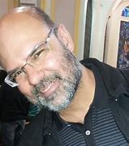 **Eduardo Bellini** **Ferreira** is an Associate Professor in the Materials Engineering Department, Engineering School of São Carlos, University of São Paulo (USP), São Carlos, Brazil, where he is a lecturer on Ceramic Materials Properties and Applications and Materials Thermodynamics. He is the Coordinator of Technology Transfer at the Center of Education, Research, and Technology in Vitreous Materials - CeRTEV (www.certev.ufscar.br). Prof. Bellini’s research interests are focused in **glass sintering**, **glass forming ability**, **glass crystallization**, **phase transformation of glasses by DSC**, and the **development and applications of glasses and glass-ceramics.**

**Daniel R.** **Cassar** is an assistant professor at the Ilum School of Science, part of the Brazilian Center for Research in Energy and Materials (CNPEM). He began his scientific career investigating kinetic processes in glasses, including crystallization, viscosity, and relaxation. His current research interests lie at the interface between Materials Science and Computer Science, particularly **in artificial intelligence tools to accelerate the development of new materials**. Daniel has published more than 30 peer-reviewed papers in internationally indexed journals and is the developer of free software tools for glass scientists; GlassPy being the most popular.

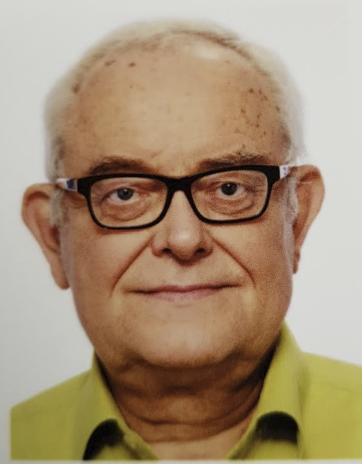 **Hellmut** **Eckert** is a Professor at the São Carlos Institute of Physics (IFSC) of the University of São Paulo and CeRTEV Vice Chair and Research Coordinator. He held professorships in Chemistry at the at the University of California Santa Barbara and the WWU Münster, before joining IFSC in 2011. He has published about 600 articles on the **methodology of solid-state nuclear magnetic resonance techniques and their application in materials science**, with a focus on structural studies of glasses and ion-conducting materials. In 2016 he received the George Morey Award of the American Ceramic Society. He is a member of the Coordination Panel in Physics of FAPESP.

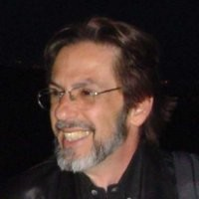 **José Pedro** **Rino** is a Professor at the Physics Department of the Federal University of São Carlos – UFSCar, São Carlos, Brazil. He has been working on the development of **interatomic potentials to describe the properties of diverse materials, including glass-formers, using molecular dynamics simulations**. Structural phase transformation induced by pressure, crystal growth, intermediate range order in amorphous solids, and its dynamical properties are some subjects of his interest.

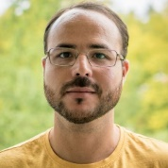 **Marcos de** **Oliveira Junior** holds a *Ph.D*. in Physics and is an assistant professor at the São Carlos Institute of Physics, University of São Paulo, Brazil, since 2019. He is interested in the **structural study of amorphous materials**, such as glasses, xerogels, and metal-organic compounds, by magnetic resonance techniques, such as: solid-state Nuclear Magnetic Resonance, cw- and pulsed-Electron Paramagnetic Resonance and Dynamic Nuclear Polarization.

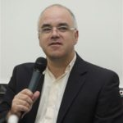 **Francisco** **Serbena** holds a *Ph.D.* from Oxford University, UK, and is currently a professor at the Department of Physics, State University of Ponta Grossa, Brazil. He has always worked with the mechanical properties of materials, including the brittle-ductile transition of metals and fracture strength and toughness of glasses and glass-ceramics. His main research focuses on understanding the underlying **mechanisms that control the mechanical behavior of glass-ceramics and its link with the microstructure**.

**Marcelo** **Nalin** holds a *Ph.D.* in Chemistry. His postdoctoral training were at University of Paris XI, France (2003), Institute of Physics University of Campinas (2007), and the Department of Physics at the Sciences Faculty of UNESP Bauru (2009), Visiting professor at the University of Bordeaux, France (2020). He was an associate professor at the Federal University of São Carlos Department of Chemistry from 2009 to 2013. Since then, he is an associate professor at the Chemistry Institute of UNESP Araraquara. His research fields are the synthesis of **new glasses and glass-ceramics for photonics**, including **the development of new synthesis routes and characterization of luminescent and magneto-optical materials and nanoparticles**. He is a member of the Technical Committee 20 of the International Commission on Glasses (TC-20-ICG) and of the Coordination Panel in Chemistry of FAPESP.

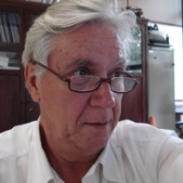 **Paulo S.** **Pizani** has been a Professor at the Physics Department of the Federal University of São Carlos – UFSCar, São Carlos, Brazil, since 1974. He has been working on optical and vibrational properties of materials using mainly **Raman scattering** to explore **temperature and hydrostatic pressure (diamond anvil cell – DAC) structural phase transformations, vibrational anharmonicity of glasses and crystals and crystallization kinetics.**

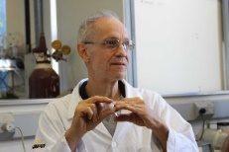 **Oscar** **Peitl** is an associate professor at the Department of Materials Engineering, Federal University of São Carlos, Brazil, and a principal investigator of CeRTEV. He did a specialization training on optical glasses at the Otto Schoot Institut and the Carl Zeiss Company in Germany in the mid 80s. He was a Larry Hench *Ph.D.* student and became a biomaterials researcher. He helped creating two **new biomaterials, the "Biosilicate" glass-ceramic and the F18 bioglass.** Prof. Peitl has also been working with **ion exchange** on a low sodium content glass, **crystallization** of several oxide glasses, and **developing scientific equipment**, such as a glass viscometer, a roller quenching device, etc.

Rafaella **Bartz** Pena holds a Ph.D. in Applied Physics and is currently a postdoctoral fellow at the São Carlos Institute of Physics, University of São Paulo, Brazil. Her main research interests focus on the structure of glass matter and the effects of extreme temperatures and gigapascal pressures on vitreous materials. Throughout her scientific training, she has applied multispectroscopic probes such as **Raman and Brillouin vibrational spectroscopies**, synchrotron techniques, and solid-state **nuclear magnetic resonance** to pursue these aims.

---------------------------------------------------------------------------------------------------------------

**NYSCC – Alfred University**

Dr. **Shan K. Sundaram** is an Inamori Professor of Materials Science and Engineering (Endowed Chair) at the Inamori School of Engineering, The New York State College of Ceramics at Alfred University appointed in 2011. Dr. Sundaram’s current research focuses on **photon-matter (ceramics and glasses) interactions** across visible to terahertz (THz) frequencies, materials processing, and characterization for various energy and environmental applications supported by DOE, NSF, DARPA, ARPA-E, and industries. He has published over 150 publications and scientific and technical reports, made over 200 scientific presentations, edited/contributed to 21 books, and taught, mentored, and supported over 200 students.

Dr. **Doris Möncke** is a professor of Glass Science at Alfred University. Topics of research range from **structure-property correlations to optical phenomena**. Her studies extend to structural modifications under external forces, unusual oxidation states of transition metal ions, and archaeometry. Doris (co)authored several book chapters and over 100 papers, she is an External Scientific Collaborator of the National Hellenic Research Foundation, Athens, Greece, and a Fellow of the Society of Glass Technology and the American Ceramic Society. She serves on the Advisory Boards of PNCS, Borate & Phosphate Conferences and is Associate Editor of the International Journal of Applied Glass Science.

Dr. **Rebecca Welch** is a Visiting Assistant Professor of Materials Science & Engineering at Alfred University. A native of Cedar Rapids, IA, Welch holds a bachelor’s degree in physics from Coe College and a Ph.D. in Materials Science and Engineering from Penn State. Her research focuses on **computational and experimental understanding of glass structures and properties,** particularly extended aluminosilicate glass compositions.

Dr. **Benjamin J.A. Moulton** has been an Assistant Professor of Glass Science and Engineering at Alfred University since August 2023. Ben earned a PhD in Earth Sciences at the University of Toronto, Canada after which he joined the Center for Research, Technology, and Education in Vitreous Materials (CeRTEV) at UFSCar in Brazil and then in the Materials Science department at FAU in Germany. Dr. Moulton’s research focuses on using **Raman and XAS spectroscopies** to investigate structure transformations that underlie anomalies in physiochemical properties, emphasizing the mechanical properties and crystallization behavior. The goal is to unify structural models to bridge gaps between the major oxide glass families.

Dr. **Collin Wilkinson** is an assistant professor of glass science at Alfred University where he is recognized as an expert in the physics of glass, as well as sustainability challenges facing the production of materials. His group continues to work on these topics, including **relaxation, nucleation, recycling, and melting technology**. Before joining Alfred University, Dr. Wilkinson was involved in multiple startup companies in glass recycling and green energy spaces. His work has been featured in several patents, over 50 international presentations, and 65 publications. He is also currently a member of the board of the GOMD division of ACerS.

Dr. **Caio Bragatto** is an Assistant Professor of Ceramic Engineering at NYSCC - Alfred University (Alfred, NY). Bragatto earned his B.S. degree in Industrial Chemistry from the Universidade de São Paulo (São Paulo, Brasil), and his Master's and Ph.D. degrees in Materials Science and Engineering from the Universidade Federal de São Carlos (São Paulo, Brasil). Before his current position, Prof. Bragatto was an Assistant Professor of Physics at Coe College (Cedar Rapids, IA; 2018-2024) and worked as a research assistant at the Otto-Schott Institut für Materialwissenschaft (Thüringen, Germany; 2016-2018). He specialized in the **ionic conductivity of glasses**, focusing especially on unveiling the mechanisms behind the phenomena and working on a universal model to predict this property. To this end, Caio conducts both laboratory and computational experiments.

**Warsaw University of Technology, Poland**

Dr. **Tomasz Karol Pietrzak** earned, from the Warsaw University of Technology (WUT), a M.Sc. in Physics (2008) and a Ph.D. in Physics (2012) with greatest honors. He is now an Associate Professor of the Faculty of Physics at WUT. His work in solid-state physics has been devoted mostly to the investigation of the nanocrystallization phenomenon in electronic and mixed (electronic-ionic) conducting glasses, resulting either in a giant increase in the electrical conductivity or confinement (stabilization) effects. His research includes both experimental and computational methods. He gained international experience during several study visits, including the Massachusetts Institute of Technology, the Rensselaer Polytechnic Institute, the University of Waterloo, and the National University of Singapore. He pays much attention to teaching new generations of physicists. He was granted numerous student awards “Golden Chalk” for outstanding didactics. He proudly serves as an advisor to Ph.D. students and surrounds himself with a young group of talented and hard-working undergraduate and graduate students.

# **INDUSTRY INSTRUCTORS**

**Dr. Satoshi Yoshida** (**AGC fellow**) graduated from Kyoto University, Japan, and got his B.E.(1993), M.E.(1995), and Ph. D.(2003) from Kyoto University. In 1995, he started to work as an assistant professor of the Department of Materials Science at the University of Shiga Prefecture (USP), Japan. From 2007 to 2020, he worked as an associate professor at USP. During the years 2004-2005, he also worked as a visiting professor at the University of Rennes 1, France. Dr. Yoshida was awarded the 14th Otto Schott Research Award (2016) from the Ernst Abbe Fund, and the Academic Achievements in Ceramic Science and Technology (2020) from the Ceramic Society of Japan. He has given >20 invited lectures at international conferences and has published 84 peer-reviewed journal papers. His main research topic is the **deformation and fracture behavior of oxide glasses.**

**Dr. Paulo Dainese** is a Principal Scientist in the Optical Physics Department at **Corning** Research and Development Corporation. Before that, Paulo was a professor at the Gleb Wataghin Physics Institute of the University of Campinas, in São Paulo, Brazil. His research is focused on the interaction between light and matter, including nonlinear optics, optical forces and optomechanics, photonic crystal fibers, hollow core fibers, and metamaterials.

**Dr. Timothy Gross –** Tim Gross is the Director of Inorganic Materials and a Research Fellow at Corning incorporated.  Tim received his PhD in materials engineering at Rensselaer Polytechnic Institute in 2008.  Tim has 151 granted US patents.  His key inventions include six versions of Corning® Gorilla® Glass, Corning® Bendable Glass, Corning® Fusion5® automotive glass, and Corning® Guardiant® antimicrobial glass ceramic.  Tim also has 34 peer-reviewed publications in the area of glass technology.

 Banu **Arslan** holds a Bachelor's degree in Chemistry and a Master's degree in the same field. She has worked as a glass technologist at Şişecam for nearly 17 years. During this time, she has led various studies focusing on glass melting and fining processes, glass composition, and batching applications. She has also managed advanced glass development projects. She served as the Manager of Melting Kinetics for four years and, for the past five months, has taken on the role of **Manager of Advanced Glass and Melting Technologies** within the Innovation Unit.

**REGISTRATION**

There is no registration fee for the school. We can cover the hotel for six nights and the lunch expenses for the selected students. The students or their thesis advisors/home institutions must cover transportation, health insurance, VISA fees, and other related costs.

Interested students must contact us by email before **December 30, 2024**, and provide:

1. An abstract of their thesis project.
2. A letter of recommendation from the thesis advisor and a commitment to cover transportation, health insurance, and other costs related to the trip and stay in São Carlos.

# **DATE and VENUE**

**March 10-15, 2025**

**São Carlos**, São Paulo State, Brazil

[The city is known as Brazil’s capital of science and technology, with approximately **2,500 Ph.D. and 250,000 inhabitants**](https://www.deepl.com/write); **1 Ph.D. for every 100 residents**. The public universities (USP and UFSCar) and the Embrapa Research Center in São Carlos are among Brazil’s best. [The city also boasts over **100 high-tech companies**, mainly in informatics, materials, optics, biotech, and chemistry](https://www.deepl.com/write). [Finally, the weather is excellent with over **320 sunny days per year**and many rivers, waterfalls, and natural forest areas around the city](https://www.deepl.com/write).

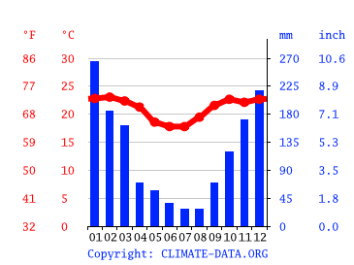

São Carlos, SP, Brazil. Average temperature and rainfall per month.

São Carlos climate: Temperature São Carlos & Weather By Month (climate-data.org)

**Nearest international airports**: Viracopos (Campinas) and Guarulhos (São Paulo). São Carlos is distant approximately 180 Km from Viracopos and 260 Km from Guarulhos airport.

South America

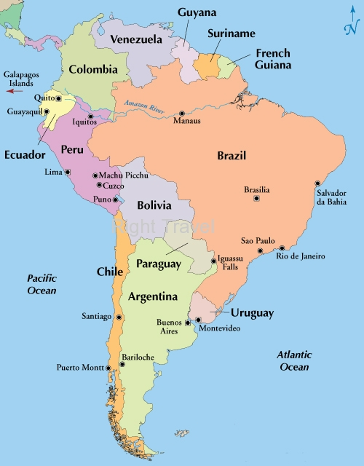

São Paulo State showing São Carlos

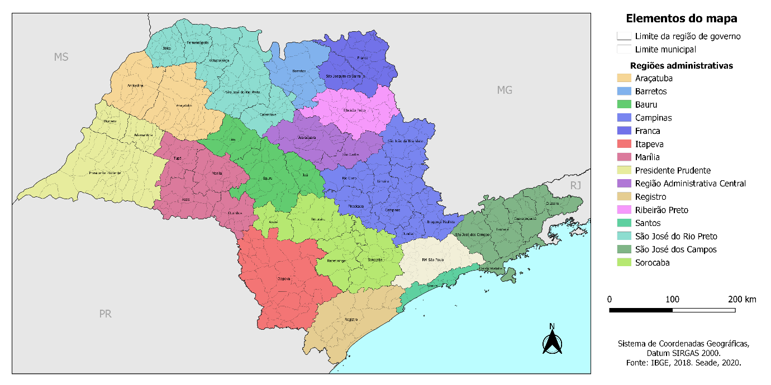

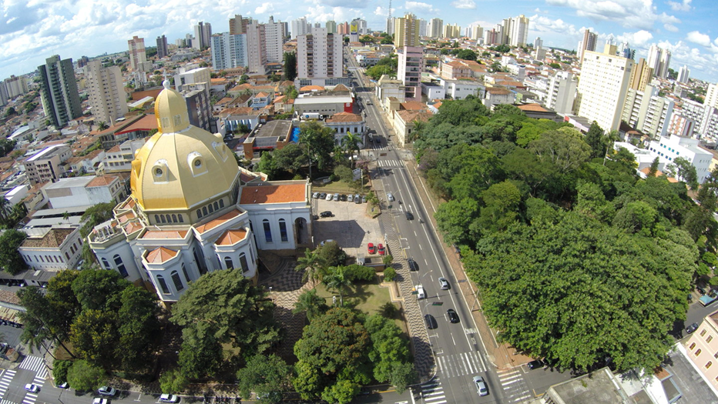Views of São Carlos city

